[**DIGITAL SIGNAL & IMAGE PROCESSING LAB**](https://github.com/Amey-Thakur/DIGITAL-SIGNAL-AND-IMAGE-PROCESSING-AND-DIGITAL-SIGNAL-AND-IMAGE-PROCESSING-LAB)

[**EXPERIMENT -**](https://github.com/Amey-Thakur/DIGITAL-SIGNAL-AND-IMAGE-PROCESSING-LAB) **4**

**PART B**

(PART B: TO BE COMPLETED BY STUDENTS)

***(Students must submit the soft copy as per the following segments within two hours of the practical. The soft copy must be uploaded on the Blackboard or emailed to the concerned lab in charge faculties at the end of the practical in case there is no Blackboard access available)***

| **Roll No. 50** | **Name: AMEY THAKUR** |
| --- | --- |
| **Class: COMPS-BE-B-50** | **Batch: B3** |
| **Date of Experiment: 04/08/2021** | **Date of Submission: 04/08/2021** |
| **Grade :** |  |

**A.1 Aim:**

Write a program to find n points to perform Discrete Fourier Transform (DFT) / Inverse Discrete Fourier Transform (IDFT) of the given complex sequence.

**B.1 Software Code written by a student:**

**(Paste your code completed during the 2 hours of practice in the lab here)**

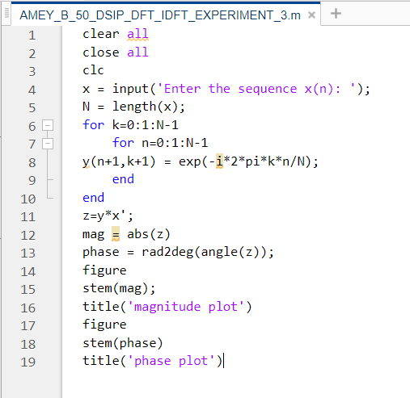

**B.2 Input and Output:**

1. **Command Window**

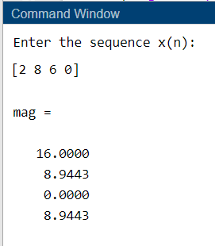

1. **Magnitude Plot**

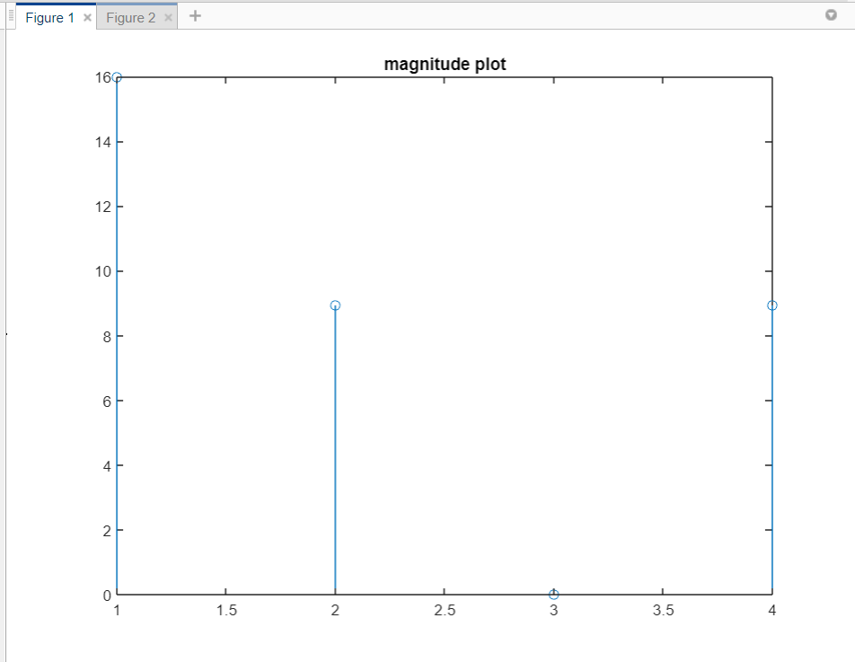

1. **Phase Plot**

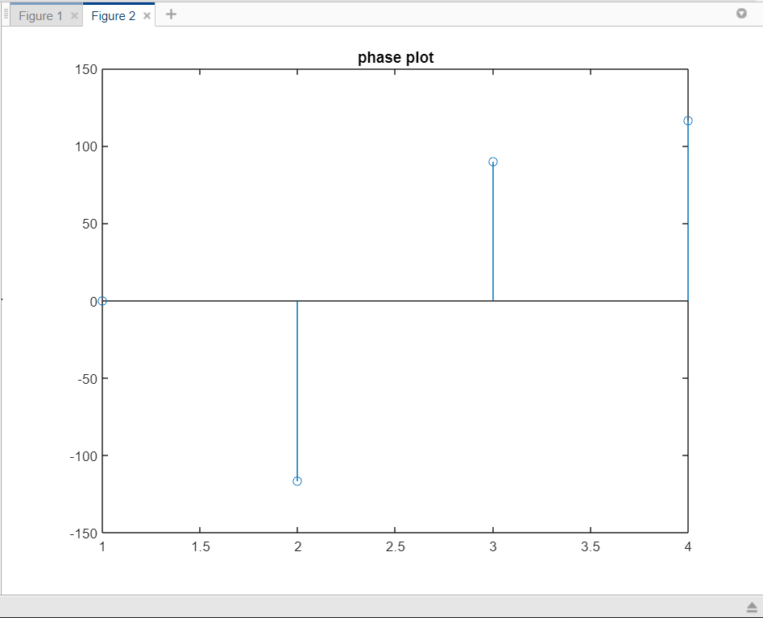

**B.3 Observations and learning:**

***(Students are expected to comment on the output obtained with clear observations and learning for each task/ subpart assigned)***

We are able to write a program that can find an n point & perform Discrete Fourier Transform(DFT)/Inverse Discrete Fourier Transform(IDFT) for a given complex sequence.

**B.4 Conclusion:**

***(Students must write the conclusion as per the attainment of individual outcome listed above and learning/observation noted in section B.3)***

After successful completion of this experiment, we are able to To develop the DFT function of the n point signal.

**B.5 Question of Curiosity:**

***(To be answered by student based on the practical performed and learning/observations)***

1. What are the different properties of Discrete Fourier Transform?

Ans: Properties of DFT

| **Sr. No.** | **Property** | **Frequency Domain** |
| --- | --- | --- |
| **1.** | Periodicity | X[k]=X[k+n] |
| **2.** | Scaling & Linearity | a1X1(k) +a2X2(k) |
| **3.** | Time Reversal | X[N-k] |
| **4.** | Circular time shift | X[k]e-j2πkl/N |
| **5.** | Circular frequency shift | X[(k-l)]N |
| **6.** | Circular convolution | X1[k]X2[k] |
| **7.** | Circular correlation | X[k]Y*[k] |
| **8.** | Multiplication of two sequences | 1/N(X1[k] .X2[k]) |
| **9.** | Complex Conjugate | X*[N-k] |
| **10.** | Parseval's theorem | $\frac{1}{N}\sum_{N=0}^{N-1}{}X\left[k\right]Y^{*}[k]$ |

1. Distinguish between DFT and DTFT.

Ans:

| **DFT** | **DTFT** |
| --- | --- |
| DFT is a finite non-continuous discrete sequence. DFT, too, is calculated using a discrete-time signal. | DTFT is an infinite continuous sequence where the time signal (x(n)) is a discrete signal. |
| DFT has no periodicity. | DTFT is periodic |
| The DFT is calculated over a finite sequence of values. This indicates that the result is non-continuous. | The DTFT is calculated over an infinite summation; this indicates that it is a continuous signal. |
| The continuous variable found in the DTFT (ω) is replaced with a finite number of frequencies located at 2πk/NTs. Here Ts is the sampling rate. In other words, if we take the DTFT signal and sample it in the frequency domain at omega=2π/N, then we get the DFT of x(n). In summary, you can say that DFT is just a sampled version of DTFT. | The ω in the exponential function is a continuous frequency variable. |
| DFT gives a lower number of frequency components. | DTFT gives a higher number of frequency components. |
| DFT is defined from 0 to N-1; it can have only positive frequencies. | DTFT is defined from minus infinity to plus infinity, so naturally, it contains both positive and negative values of frequencies. |
| To improve the accuracy of DFT, the number of samples must be very high. However, this will, in turn, cause a significant increase in the required computational power. So it’s a trade-off. | More accurate |
| DTFT and DFT will coincide at intervals of omega=2ωk/N where k = 0,1,2…N-1. | DTFT will contain some of the values of DFT too. |

1. What is the State and prove circular time-shifting and frequency shifting properties of the DFT?

Ans:

1. Circular Timeshift:

The Circular Time shift states that if

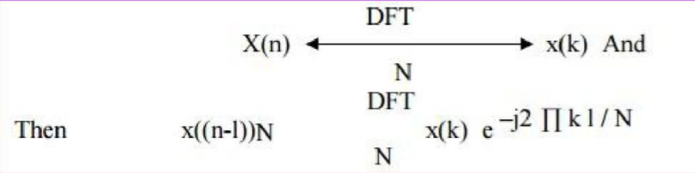

Thus shifting the sequence circularly by l samples is equivalent to multiplying its DFT by e-j2 Π k l/N.

1. Circular frequency shift:

The Circular frequency shift states that if

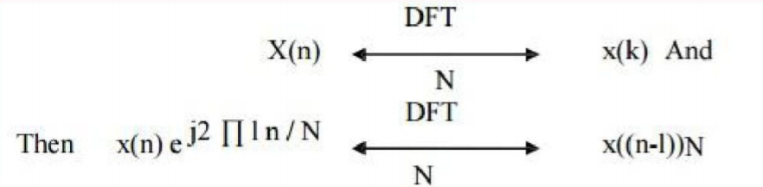

Thus shifting the frequency components of DFT circularly is equivalent to multiplying its time-domain sequence by e-j2 Π k l/N.